# A Simple Chat App

**Team Members:**

* Rhythm Arya 2k18/IT/094
* Rishabh Jain 2K18/IT/097



**Introduction:**

The WebSocket API is a way to communicate between a client (user's browser) and a server. During the session, the data can flow bi-directional way in real-time, meaning the client can send the messages to the server, and the server can response back without the need to poll. Communication through the opened channel is long-lasting and low latency.



**ARCHITECTURE:**

First of all, we have to separate two parts in the development of an application: the client part and the server part. We will have to develop the two parts to make our application up and running.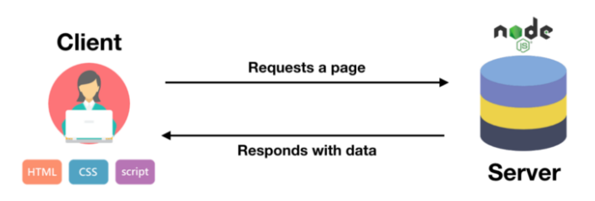

The server will be handled by node.js to make all the engineering i.e launch the packages and the website.

The client part will be loaded on the computer of the client.

**TECH STACK**

1. Node js

2. Express js

3. Javascript

4. HTML

5. CSS

6. Bootstrap



**RESULT:**

A simple chat web-app developed which shows a real time communication between several clients and a server.



**ADD ONS:**

* A registration system with the possibility to chat in a one-to-one chatroom
* History of all the conversations
* Online/offline labels

